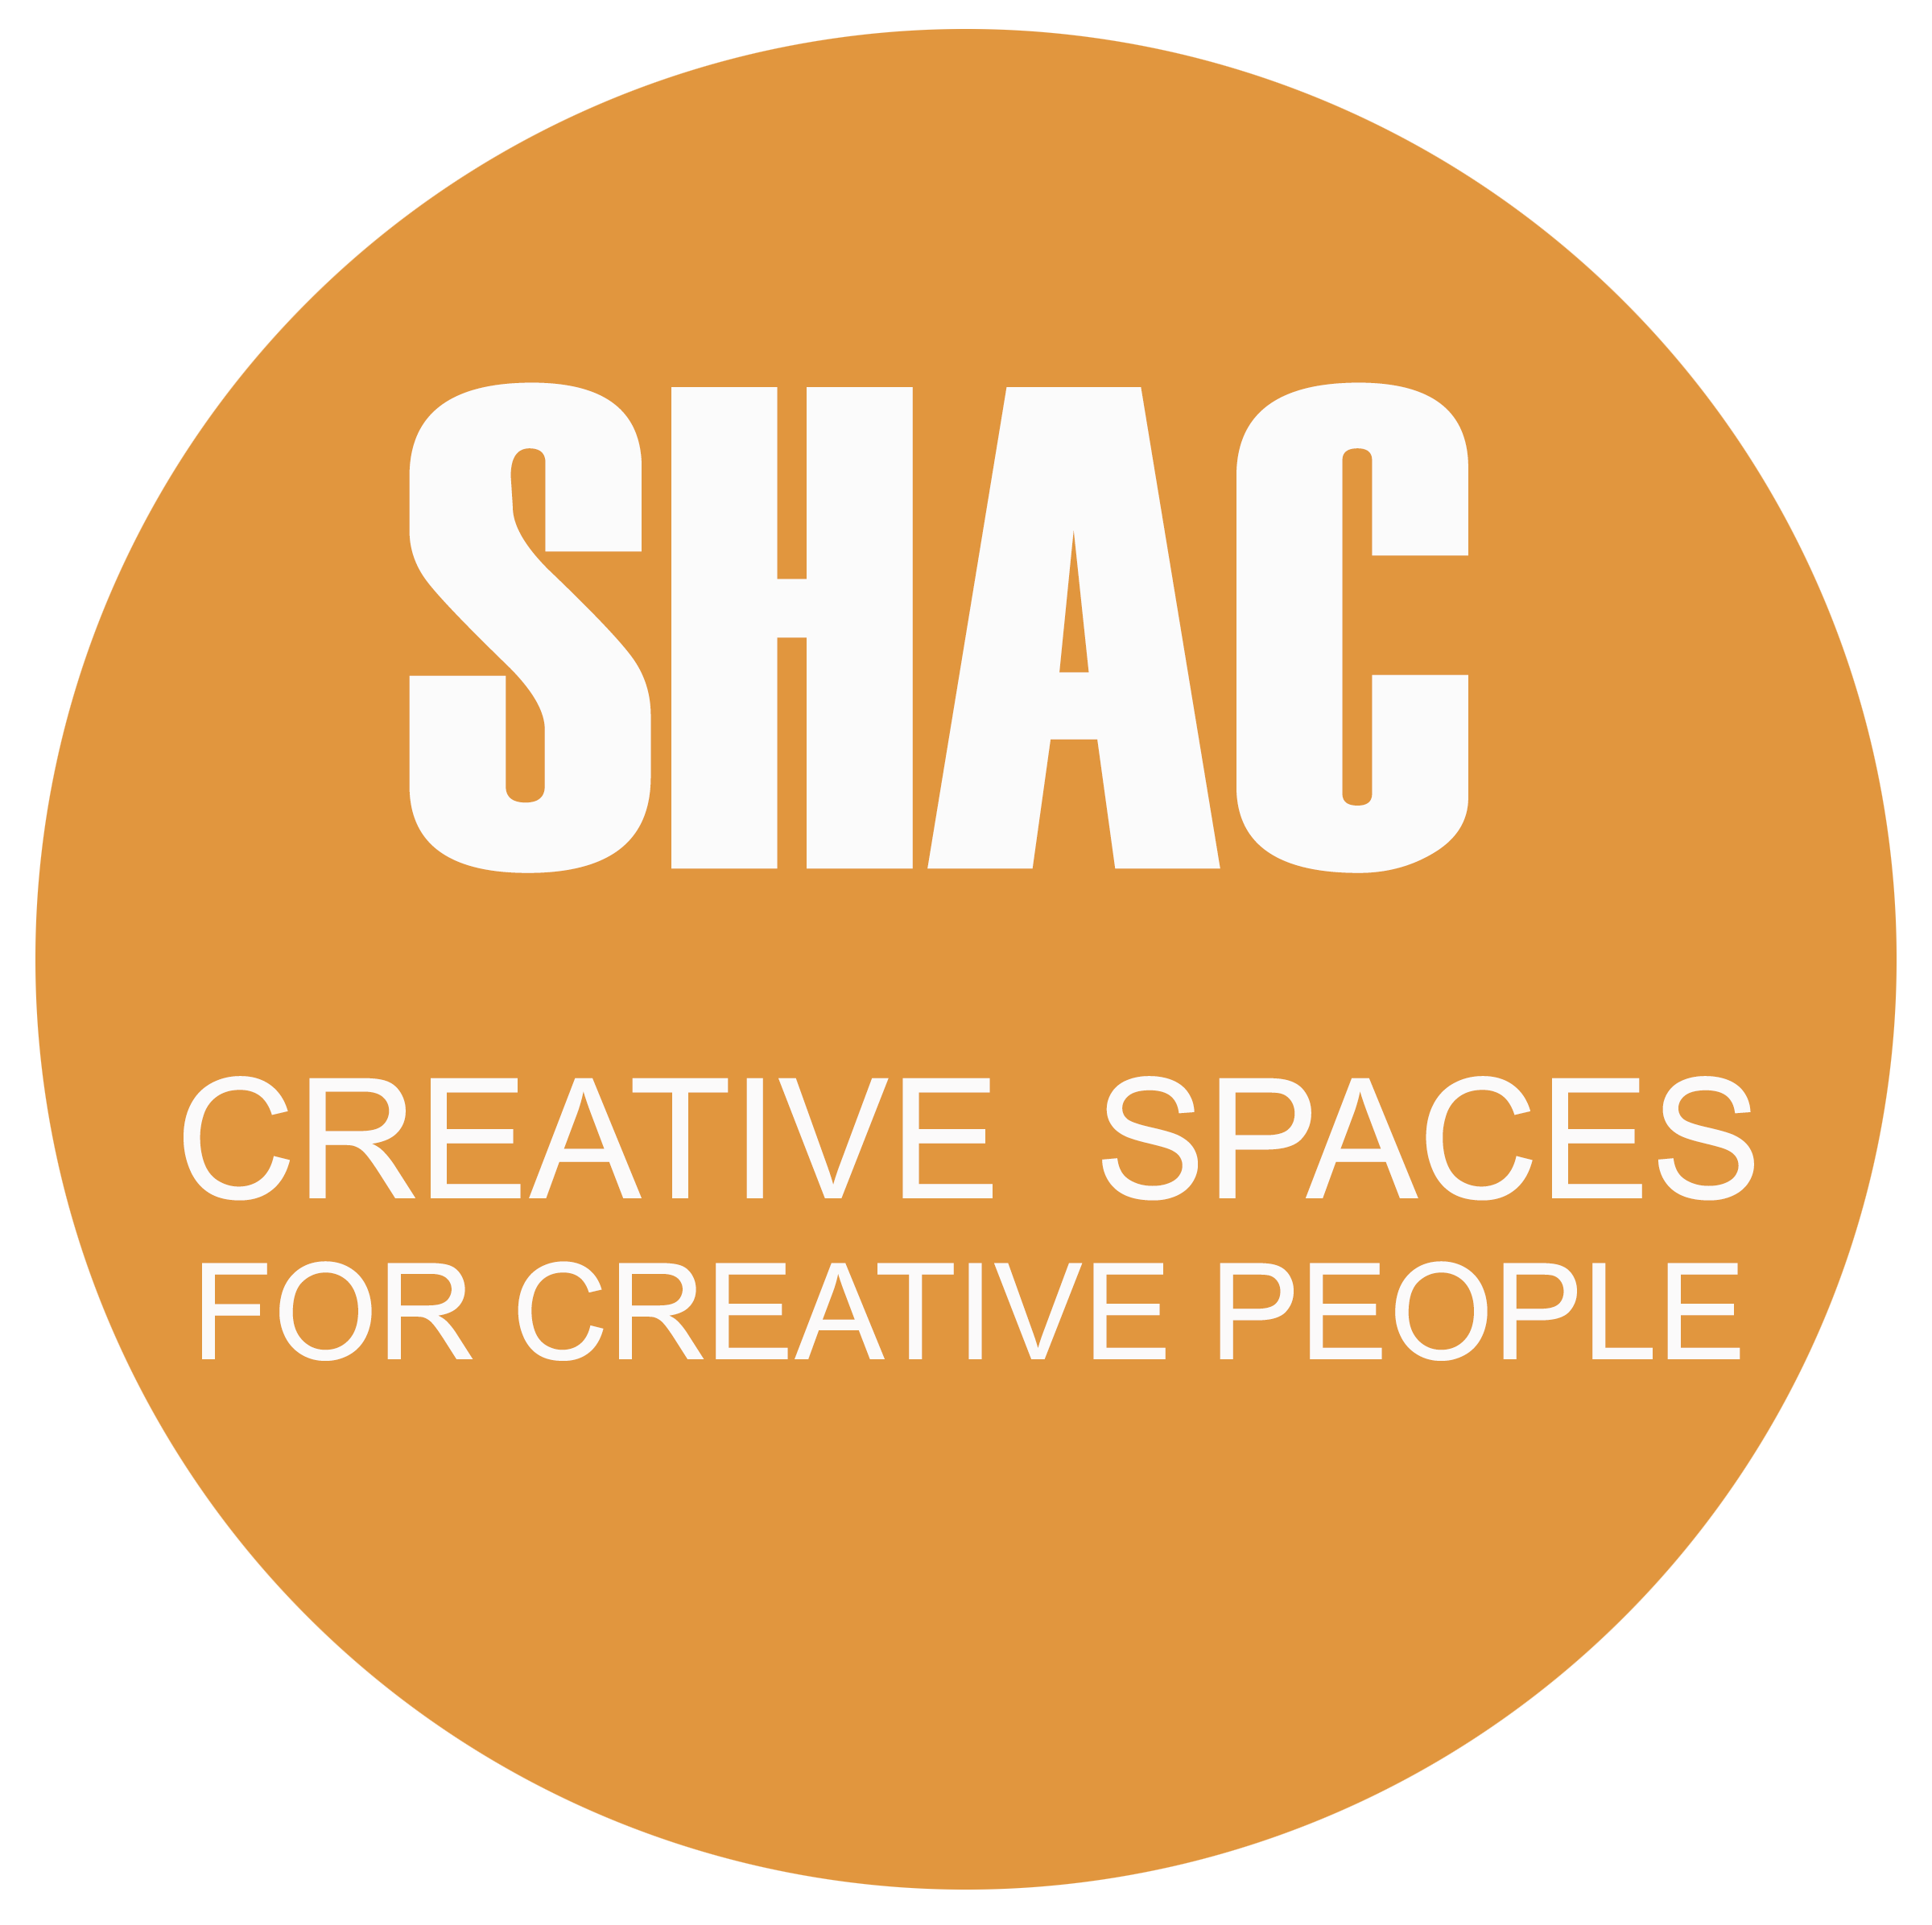

Sustainable Housing for Artists & Creatives

Expression of Interest
Information Pack
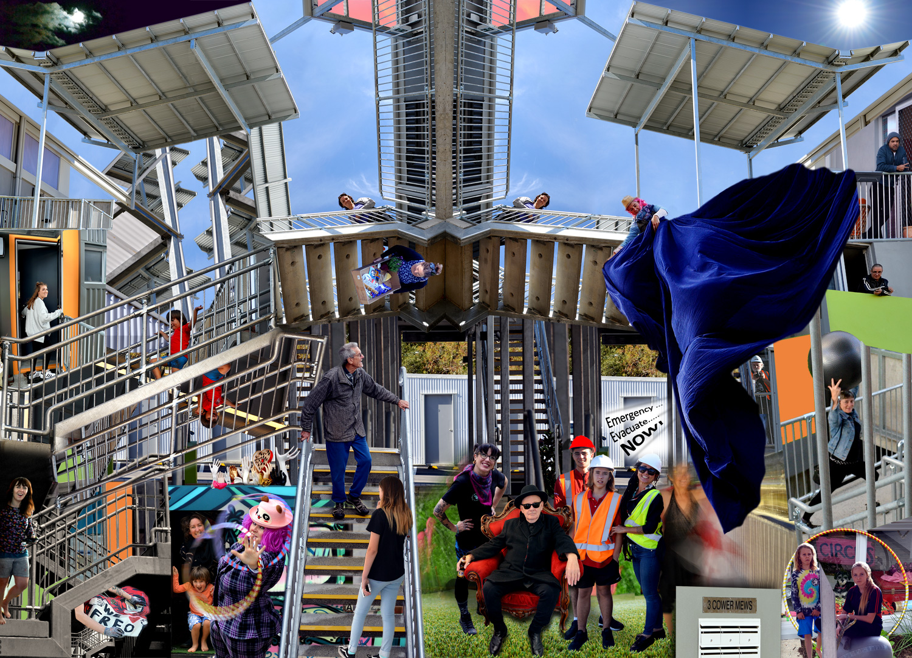
March 2019

Thank you for your interest in becoming a member of SHAC, and joining us in this exciting, ground breaking endeavour. As a cooperative community of dedicated low-income creative practitioners we are committed to securing affordable sustainable housing and co-working spaces in Fremantle for artists and creatives.

Over the years, rising property prices and a crisis in affordable rental space have had an impact on Fremantle’s art community, forcing many to leave. SHAC endeavors to make it possible for artists and creative people to remain living and working in Fremantle, and to secure Fremantle’s reputation as a centre of creativity and the arts.

In the long-term our goal is to create social and cultural capital contributing to Fremantle’s cultural sustainability by securing this cooperative and its buildings as a permanent resource for the community.

The SHAC development
SHAC is a high quality, affordable and sustainable rental housing community in White Gum Valley, located in the WGV precinct close to Booyeembara Park and Sullivan Hall. The buildings have been architecturally designed to strike a balance between community and private space as well as having a low carbon footprint in construction and maintenance.

- The dwellings are made up of a mix of one, two and three bedroom apartments, each with its own private courtyard or balcony space.
- All residents respect the balance between each person’s private life and community living.
- Housed members are currently in a rental lease agreement with Access Housing and income is assessed to determine rent amounts which are paid on a fortnightly basis to Access Housing.
- Pets are allowed as approved by Access under the rental tenancy.
- Two community studio spaces that we name CoLab1 and CoLab2. Both these spaces are soon to be launched with a yearly program of exhibitions, performances and workshops.

An onsite solar array and battery system powers the building. This was supplied under the ARENA Funding Agreement and Curtin University for the Project ‘Increasing the uptake of solar PV, using energy storage, monitoring and micro grids within strata residential developments in Australia’. Access Housing entered into an agreement with LandCorp and Solar Balance for the installation of onsite generation system. Energy generated can be traded peer-to-peer using the Power Ledger platform.

SHAC is proud, and privileged, to be part of the broader White Gum Valley (WGV) development - a sustainable living project committed to the international standard of the One Planet Living principles.

The WGV development is only the eleventh in the world to hold One Planet Living accreditation, and SHAC itself is working toward the goal of ‘carbon neutrality’.
For more information visit: https://www.landcorp.com.au/innovation/wgv/initiatives/One-Planet-Living/

SHAC is a not-for-profit, non-distributing cooperative
The global Cooperative Principles and values that guide us are based on the concepts of ‘self-help, self-responsibility, democracy, equality, equity and solidarity’. The cooperative movement has a long and strong history in Western Australia, and ‘in the tradition of their founders, co-operative members believe in the ethical values of honesty, openness, social responsibility and caring for others’(Cooperatives Act 2009).

SHAC operates under a Project Agreement with affordable housing developer Access Housing, the City of Fremantle and Landcorp. One of the ways in which SHAC, (and our champions and supporters) are thinking creatively is in the designing of shared equity models in order that residents could make a transition from renting to owning their living space.

Our Cooperative Structure consists of a board of directors, elected from the SHAC membership at the SHAC Annual General Meeting. SHAC is a democracy so all members have equal voting rights: 1 Member - 1 Vote.We have three main Subcommittees and various Working Groups that assist them as the need arises.

The Board reviews all membership applications. The SHAC rules require that, in order to be approved, applicants for membership must have completed the Induction Program and the Board must be satisfied that the new members will be able to meet the Active Membership Test on an ongoing basis. If approved, the applicant’s name, the date and any other information required under the Cooperatives Act, will be recorded in the register of members. The applicant will be notified in writing of the entry in the register and will then be entitled to the privileges attaching to membership.

Members sustain the cooperative by abiding by the principles of cooperatives outlined above, through shared work in the form of voluntary hours, and a small regular financial contribution.

There are some criteria SHAC uses to determine the cultural and creative contribution of members and to confirm that they are remaining active as members. You will learn more about this at your Induction Session should you wish to apply for membership.

Our cooperative is ‘Limited By Shares’, which means it raises capital through shares, and that the limit of each member’s financial liability, in the event of a collapse of the cooperative, would be the forfeit of an individual share.

If your membership is approved, the Board will make you an offer of purchase of 1 A Class Share at $1200. Only members can hold shares and it is a requirement that to be eligible for tenancy a member must hold a Share. At the time of becoming a member you would be required to pay a minimum of 10% deposit of the full amount ($120). Arrangements would then be made to pay the remainder via agreed installments or a payment plan.

Benefits of Membership

- Opportunity to be on the Waitlist for affordable and sustainable housing

- Opportunity to be a part of an active, like-minded, community who will support you and your practice.

- You will be able to enjoy use of the Co-Lab spaces, at members rates, this will give you opportunities to run workshops, and to share the skills you possess.

- Opportunity to be part of artistic collaborations in art projects with the local community and with other SHAC members

- Opportunities to generate income to support your arts practice or your special interest group

- Opportunities to gain skills in arts practice, community engagement, sustainability, and the business of forming and running a cooperative venture

- Opportunity to be part of the One Planet Living philosophy and work toward the goal of ‘carbon neutrality’

- Opportunities to Special Invitations to SHAC events e.g. soirees, jams and dinners.

- Training and experience in business skills, project planning, fundraising and governance.

As a member of the cooperative you will be encouraged and supported in your practice and in return will be volunteering time and business skills to the project and its financial success. Members are required to contribute 60 hours per year while on the tenancy waiting list and 150 voluntary hours per year if a tenant. The benefits and pleasures of working together in this innovative and unique artist-run initiative far outweigh the obligations.

Access Housing Criteria

Access Housing and SHAC are partners in this development. SHAC residents rent their dwellings from Access Housing, and rental amounts are subsidized by NRAS (National Rental Affordability Scheme) NRAS will be applied to the tenancies until June 2025. NRAS has guidelines as to what constitutes ‘low to moderate income’, and members applying for SHAC will be assessed by NRAS and Access Housing accordingly. You can get more information from the Access Housing NRAS Tenant Fact Sheet.

So, Artists and Creatives out there - come and join us if can see yourself working, and perhaps living, with this vibrant group of talented, experienced and dedicated people in the future!

Just submit the Expression of Interest form that is included in this document and a professional biography or CV (photos of your work if applicable)to SHACfreoartists@gmail.com

After sending us your EOI, you will be invited to an Induction Session, these are held regularly throughout the year. At this session we’ll give you a tour of the development and some of the homes too. You will find out more about the people, the background story of SHAC, and how it all works.

While enjoying refreshments with some of the other members and residents, you’ll also find out what it means to go to the next stage of becoming an Applicant.

SHAC aims to live sustainably, to sustain our members’ arts practices, to contribute to the good of the wider community and to secure a sustainable community asset for the future.

And we aim to be creative and to have fun!

Information provided from http://www.dss.gov.au/our-responsibilities/housing-support/programs-services/national-rental-affordability-scheme/fact-sheet-tenant-eligibility.

